**A&L Engineering**

**Supply Drop Plan**

# DIAGRAM

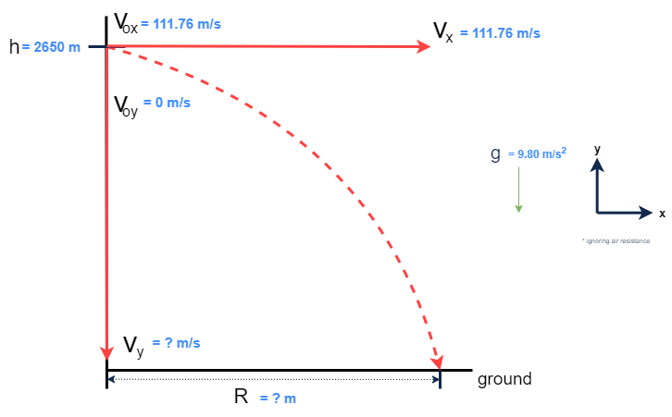

# INITIAL CALCULATIONS

# Converting to S.I. units:

$v_{0x}$ = $250\frac{mi}{hr}*\frac{1609.44 m}{1 mi}*\frac{1hr}{60 min}*\frac{1 min}{60 s}=111.76\frac{m}{s}$ $≅112\frac{m}{s}$

# Final Horizontal Velocity: (Constant horizontal velocity, ignoring air resistance):

${v_{x}=v}_{\begin{aligned}0x \\ \end{aligned}}=111.76 \frac{m}{s}$

# Time in Air:

$h = h_{0} + v_{0y}·t +\frac{ 1}{2}·a·t^{2}$

$$2650 m = 0 + 0·t +\frac{1}{2}·g·t^{2}$$

$$2650 m =\frac{1}{2} · 9.80 \frac{m}{s^{2}} · t^{2}$$

$$2650 m =4.90 \frac{ m}{s^{2}} · t^{2}$$

$$t = \sqrt{\frac{2650 m}{\frac{4.90 m}{s^{2}}}}$$

$$t≅23.255458 s≅23.255 s$$

## 

# Final Vertical Velocity:

$$v_{y} = v_{0y} + a·t = 0 +9.80\frac{ m}{s^{2}} · 23.255458 s≅227.903488 \frac{m}{s}≅227.90 \frac{m}{s}$$

# Final Total Velocity:

$$v= \sqrt{{v_{y}}^{2} + {v_{x}}^{2}}=\sqrt{\left({\left(227.903488\frac{m}{s}\right)}^{2}+ {\left(111.76\frac{m}{s}\right)}^{2}\right)}≅253.831238 \frac{m}{s}≅253.83 \frac{m}{s}$$

# Horizontal Drop Distance:

$$R = v_{0x} + v_{x}·t = 0 + 111.76 \frac{m}{s} · 23.255 s = 2598.9788 m≅2599.0 m$$

## Description

$$v_{0x}=initial horizontal velocity (\frac{m}{s})$$

$v_{0y}=initial vertical velocity \left(\frac{m}{s}\right)$

$v_{x}= final horizontal velocity (\frac{m}{s})$

$v_{y}=final vertical velocity \left(\frac{m}{s}\right)$

**v** *= final total velocity $\left(\frac{m}{s}\right)$*

**a** *= acceleration = g = 9.80 $\frac{m}{s^{2}}$*

**t** *= time payload is in the air once dropped (s)*

**h** *= height to drop payload (m)*

**R** *= horizontal distance from target (m)*

In Kinematics, horizontal and vertical motion are independent of each other, but they do have a relationship via time. In projectile motion of a free-falling object, the greater the amount of time in the air, the greater the final vertical velocity. With no air resistance, the horizontal velocity is constant.

**The total (final) velocity can be found with the Pythagorean Theorem:**

$v = \sqrt{{v_{x}}^{2} + {v_{y}}^{2}}$

# MODIFIED SCENARIO ONE

## Diagram

## 

## Source: National Oceanic and Atmospheric Administration.

## “[National Weather Service](National%20Weather%20Service)”.*7/22/2022, https://www.weather.gov*

## Description

# Converting to S.I. units:

$v_{wind}$ = - $18\frac{mi}{hr}*\frac{1609.44 m}{1 mi}*\frac{1hr}{60 min}*\frac{1 min}{60 s}=8.0472\frac{m}{s}$ $≅8.0\frac{m}{s}$

**Head wind only affects horizontal motion, so:**

$$v_{y}≅227.90\frac{m}{s} AND t=23.255 s$$

**Adjusted horizontal velocity:**

$v_{x}$ = $v_{0x}-v_{w}=111.76\frac{m}{s} - 8.0472\frac{m}{s}=103.7128\frac{m}{s}≅103.71\frac{m}{s}$

**Horizontal distance should be less at a slower horizontal velocity:**

$R= v_{x} ·t=103.71\frac{m}{s} ·23.255 s=2411.77605 m≅2411.8 m$

The 18 mph (or 8.0 m/s) headwind caused the horizontal velocity to decrease; however, no change occurred to the vertical motion. The decreased horizontal velocity requires a smaller horizontal distance from 2599.0 m in the original plan to 2411.8 m in this scenario.

# MODIFIED SCENARIO TWO

## Diagram

## Description

**Final vertical velocity:**

$$v_{y}= v_{0y}·sin θ=67\frac{m}{s}·\sin{50}°≅51.3249777≅51\frac{m}{s}$$

**Final horizontal velocity (ignoring air resistance):**

$$v_{x}= v_{0x}·cos θ=67\frac{m}{s}·\cos{50}°≅43.0667698≅43\frac{m}{s}$$

**Air-Time:**

$t =\frac{ R}{v_{x}}=$ $\frac{400 m }{43.0667698 \frac{m}{s}}≅9.28790345≅9.3 s$

**Vertical height:**

H = $v_{y}·t+\frac{1}{2}at^{2}=51.3249777\frac{m}{s}·9.28790345 s+\frac{1}{2}\left(-9.8\frac{m}{s^{2}}\right)\left(9.28790345^{2}\right)=54.0022 m≅54 m$

* 54 m > 50 m, so the payload will reach (and pass) the target site

Changing the starting velocity or angle of the catapult would alter the distance needed to reach the target site. A lower velocity or a steeper (larger) angle (relative to the horizontal plane) would be more precise, in this case.